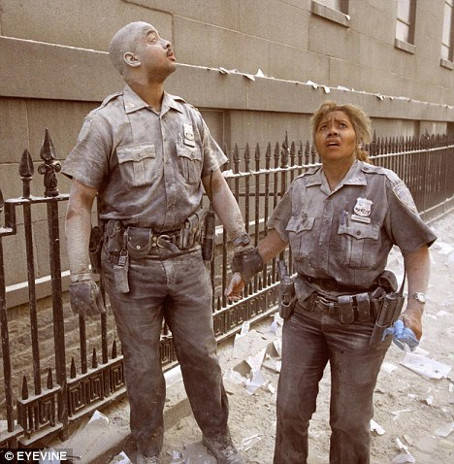

~Honor~

~Courage~

~Compassion~

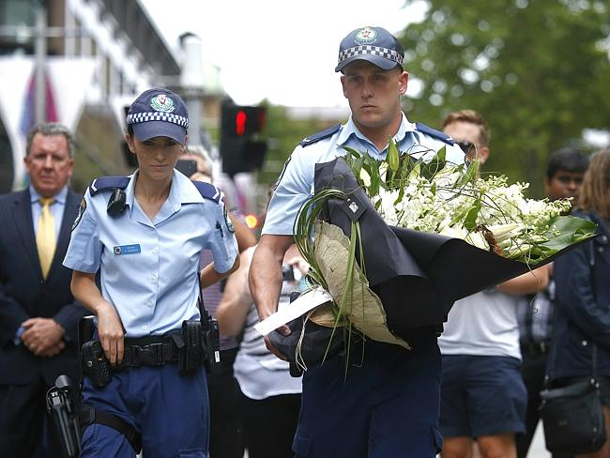.
Geelongadvertiser.com
ISSUE OF CONERN:
There is currently an extensive amount of negative controversy and social media that is giving police officers a bad reputation.
OBJECTIVE:
To raise awareness to society of the personal sacrifices that are made by police officers in order to do their job each day.

~ It takes a special kind of person; a selfless and brave individual, to see past themselves in order to protect and serve others.

Many of us get up each day to go to work and earn a living for our family. Imagine looking in the mirror and seeing the reflection of yourself standing in your uniform. Picture your badge reflecting light from the early sunrise coming in the window. Your career is dangerous. You could die on duty. Your life is in the hands of split second responses to urgent situations and other people’s poor choices. Envision yourself, knowing the pain and suffering that would consume your family and your children if this was their last glimpse of you, walking out the door.

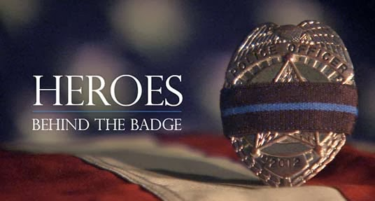
www.hpdblog.com
Giving Recognition where
Recognition is Deserved

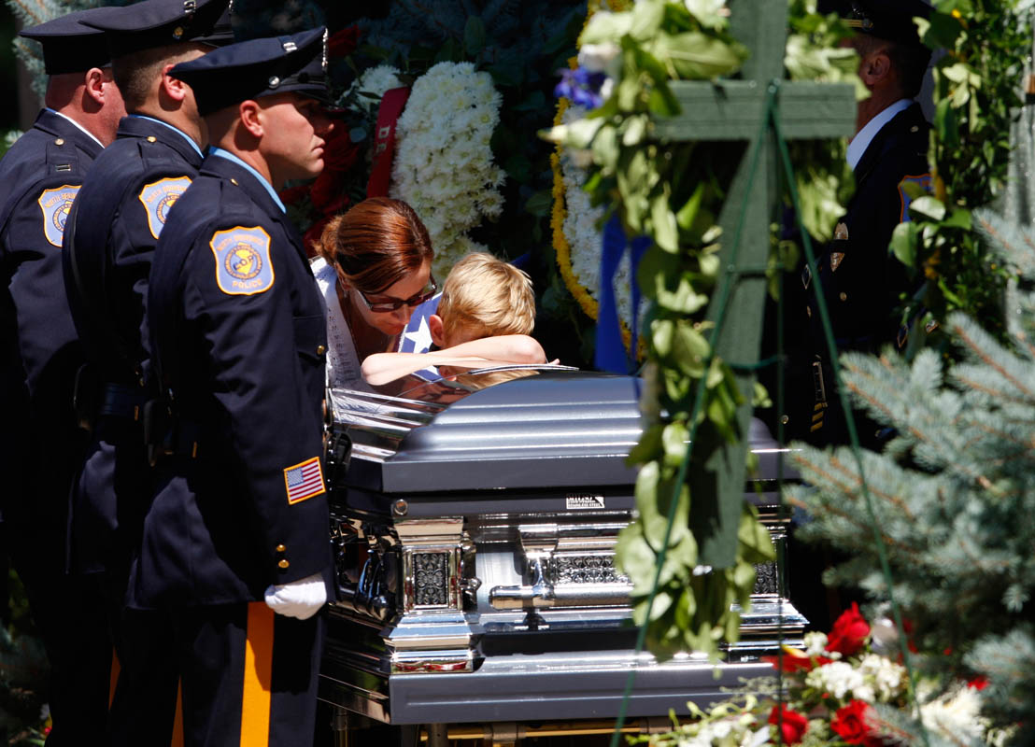
Frankconlon.com

Dedicatedtoheros.blogspot.com

Supporting our
Men in Blue

The men and woman of law enforcement put their lives on the line each and every day.
They know the risks and they still take it.
“Our Unsung Heros”
Our Fathers,
Our Mothers,
Our Children,
and Our Brothers and Sisters.

References:
Utahsfallen.org
KSL.com
Salary.com
www.hpdblog.com

What Can We Do?
We can come together as a society, and recognize our officers that protect and serve, enforce, and put their lives on the line each and every day. We can think twice about negative media attention and understand that there is more than one side to every story. We can empower ourselves to spread positive attention about our Men in Blue to washout the bad wrap that they have become accustomed to each day. Quite simply, if we see an officer, we can say hi. We can give them a nod, a wave, or a thank you for all that they do.
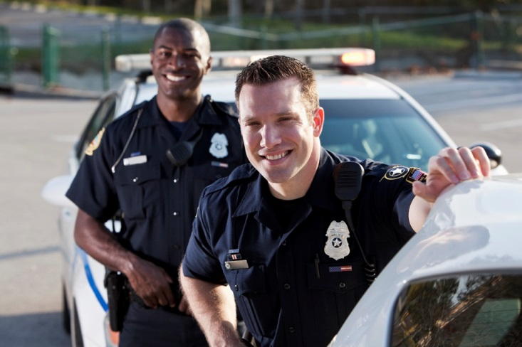
www.infraware .com

Brennerbrief.com

Can You Put a Price On Life?
- According to Salary.com, the median annual police patrol officers salary is SLC is $49,863.
- This wage is below the national average and doesn’t take into account the overtime the officer puts in.
- It does not reflect the mental and emotional toll that comes with the job.
- It does not take into account the on the job risk and resulting anxiety and stress.
- According to Utahsfallen.org, 137 officers have been recorded to have died while on duty in Utah.
- This statistic accounts for all historical fatalities, 56% to homicide and 44% considered accidental.

Can Just Anyone Become an Officer?
Absolutely not! In order to even be considered to join the police force, interested individuals must go through an extensive background check, testing, as well a waiting list for sometimes months to years; before even being considered to attend the police academy.

Is That All?
Not quite. Even after an individual gets the opportunity to enter the police academy, they must be able to endure 21 weeks of rigorous training. Training includes:
- Physical adaptation and handling firearms.
- SLC laws and procedure education.
This is followed by a pinning ceremony where recruits are inspected and give their oath of office. They must then go through 12 more weeks of on the job training before they are officially on their own; according to ksl.com-Salt Lake Police Academy graduates 12 new officers, May 10, 2011.
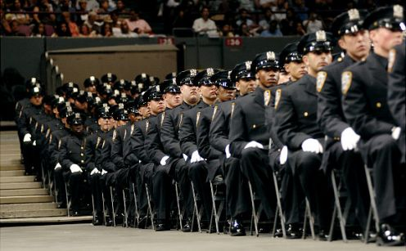emeasy.hubpages.com
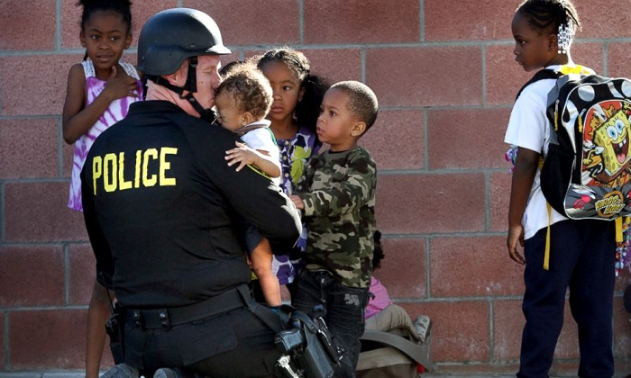

Supporting our Men in Blue

