Annie Varner
Louise Bown
English 2010
26 April 2016
Perceptual Deviation
The sun beat down harshly all day at the splash pad. Running through the cool chlorine filtered water, each splash of coolness was a therapeutic touch of relief. I recall the smell of the dry air as I sit on the grass to dry off for a moment. Dry weeds, a fire hazard to have on such a hot summer day. I founnd myself thankful that smoking is prohibited in the park; what a tragedy it would be to lose such a prized gem to the carelessness of some fool puffing away. I closed my eyes for just one moment to take a deep breath in and meditate with sunshine. A distant rustling of the grass closed in as I feel a shock to both of my legs; “Mommy, feel my hands, they are so cold!” I open my eyes in surprise and smile in pride at the silhouette of my little one running back to the splash pad before I could reply. (Picture courtesy of www.eventbrite.ca)

I admire the happiness on their faces, my beautiful perfect children. I understand that I am biased; most parents are as they picture their children to be flawless and special. I admire the contrast and array of skin tones of the children on the splash pad. It was a melting pot that day with many children of diverse ethnicities collaborating and organizing a water fight with plastic cups. I recall my fondness of how colorful society has become with the many interracial blends of children. We have taken strides since the civil war. Like a canvas, the many shades of skin color provide a beautiful contrasting image as the children interact with each other on the splash pad. I appreciate my child’s nice olive complexion that is an equal blend of her father’s chocolate complexion and my very own light, sun reddened skin tone.
I recall questioning myself critically as to see the other side of the spectrum. Will my children have the opportunity to live in peace for the duration of their lives? Have we evolved enough so that my children will escape the harsh brutal hatred that has scorned our past? Will I be able to protect them so that they will never have to endure racism? It was that day that my perception was clear as glass; and on that very same day it was tested by the deviation of another person’s negativity. My perception was tried by the ignorance of a complete stranger making assumptions simply by racial profiling.
As I pondered my childhood, I recalled the excitement I felt each Sunday as a child, singing and clapping at a Baptist church and admiring with such interest the dark skinned members who would stand up and praise the lord with such character and animation. It was with my ethnically diverse best friend and her family, who I would accompany to church. Since I could remember, skin color was a fact, no emotion or judgement attached. Being a child was simple. I perceived nothing but people with different hues and shades, like a variety of colors in a box of crayons. Life was that simple for everyone, right? All people were created to be open minded and willing to accept others and see beauty in them? People are judged by the color of their skin, but by their character, right? Just as everyone else, my perception was shaped by my own personal experiences. The behavior and opinions of the adults in my life, and the ways I was treated by others. It is not common for a Caucasian female growing up in a middle class neighborhood, to be treated with racism and prejudice by others.
Back to this hot summer day, I recollect my husband and I getting the kids together and loading them into our toasty minivan. Lily pouts as daddy puts her in her car seat. A big teddy bear: that is how I perceive my tall strong dark skinned husband. I began to ponder our conversations from when we began dating several years ago. “How are you today ma’am”, my husband would say to the southern woman at the cash register at Walmart. “Fine”, she would respond with distain. I was curious why such an interaction took place. My husband explained to me that every time he sees this woman she behaves in the same way, and he responds accordingly; with kindness and respect. He has shared stories from his childhood of being treated differently because of his skin color. From teachers who would publicly humiliate him, to police officers who have pulled him over and searched him for no reason at all; and to find nothing worth searching for. I recall thinking in my head that perhaps maybe he was blowing things out of proportion? I have heard so many claims of racial profiling by minority groups on social media. I also know that there is always more than one side of a story. Looking back, I realize how ironic it was that my day would end with such a strong message to set my mind at ease.
The sun was almost set, with a gleam of light streaming in the dark blue sky. The refreshing cool air from the AC caressed my face as the van filled with nice cool air. The traffic was not bad at all for an evening drive towards home. Kind, my husband was always kind when others would least expect it. Once we went to the grocery store. I recall grabbing some bread from the next isle over, and walking back to my husband only to watch an elderly women take her purse and grasp it ever so tightly and tuck it on the side opposite of my tall dark prince. She did this as she approached my husband who was innocently counting oranges and placing them on a scale. He had no idea, but just looked at the elderly woman and smiled. “Good evening, ma’am”, he said with a welcoming tone. It was as if he had two very soft spots in his heart; one for the very young and another for the very old. Just last week he gave me a startle as he stopped from backing out of a parking space. The gear flew into park and before I could say anything, he was out the door running towards another vehicle. There an elderly woman was falling over as her adult daughter was struggling to assist her into the passenger seat. I admired him for his big heart and willingness to help others.
I call to mind, the arguing of my children over what movie they wanted to watch. Just then, my husband had shut off the tv since the kids were not willing to cooperate. While I can see the lights dim behind me, I could also see new lights arise from outside the vehicle. To be more specific, the colorful array spiraling behind us was police lights. “Pull over, that is a cop!” I exclaimed. I recollect an instant change in domineer on my husband’s face as he pulled our vehicle over to the side of the road. His hands grip the steering wheel as he looked in the rear view mirror to assess the police officer’s actions.
The police officer approached the window and used his knuckle to tap as he stood defensively grasping his gun on his hip. My husband rolled down the window and looked at the officer. Before he could say anything, the police officer looked at him and said: “Where are you headed from tonight?” I instantly found myself offended, since I have never been approached by a police officer in such an abrupt manner. I couldn’t help but feel as though he was targeting my husband. In a deep stern voice, my husband replied, “A family outing”. The officer still stood with a guarded stance as he went on; “You have tinted windows, is anyone in the back seat of your van?” I could feel the tension, as my husband obviously felt that the officer was being nosey and intrusive. “My kids”, my husband grunted, “Do you have a reason for pulling me over?” At this point, I felt the urge to intervene as the tension became as thick as mud, and I nearly felt the frustration my husband was experiencing. The police officer stated: You failed to yield at a stop sign. Can I see your license and registration? My husband glared at him and replied, “Yield, who yields at a stop sign?” Before anymore words were passed, I reach over my husband in an attempt to break the tension, to hand the registration over to the officer. My husband reached in his pocket and pulled out his wallet. He kept his eyes on the officer, as the officer responded. “You did not stop. At the stop sign, you did not stop.” He then asked my husband to roll down the back window so that he could see the back seat. At this very moment, my momma bear instincts kicked in, as this police officer was about to imprint an early unfavorable memory upon my children. This was now an incident that may very well affect my children’s perception of police officers for the rest of their lives. I leaned over and said to the officer with a kind voice “Excuse me officer, our three children are very sleepy and tired from playing at the park. If you would like, you may take a peek into the back seat, but I do not want them to get scared. Now officer, are we being detained?” I recall the officer rethinking his intentions with each crease he made in his forehead. “Hold tight for just a moment, I will be right back, the officer replied”.
I recollect the fury I had blazing inside me with this officer. How dare he approach my husband and my family in such a manner? How would he like to be pulled over and handled in such a way while his children and wife sat and watched? How dare he treat my husband as if he is a criminal? I just now notice that my husband had turned the movie back on to divert the attention of our children. “What happened daddy, why is the police here?” My husband’s heart opened ever so gently as he replied to our son; “He is just making sure we are all following the laws, son. That’s all.” Following the laws, really? I cringed as the officer’s facial expressions replayed in my head. I resented this officer for thinking that he was above the law! The ignorance of that officer and his actions brought me to a realization that I was contemplating for years. I now understood my husband’s perspective. I could now put myself in his shoes and see from his perspective.
I said to my husband as the officer approached: “What a racist idiot!” At that very second my husband’s domineer changed completely. His eyes, mouth, and even his muscle tone took to my statement with a deep sadness. Was it guilt he felt, as though he was repenting his actions and words like he had fed me a poison he wished to extract from a wound? Was it sadness that he wished he could sweep away from me, to protect me from the hate he has been afflicted with so many times before? Whichever revelation he had, he instantly changed his stance. The officer now was knuckling the window again. The officer’s domineer was left unchanged as he approached with a distasteful look on his face and distain in his voice. On the other hand, my husband’s eyes smiled, and he lit up like an angel as he turned towards the officer and said “That stop sign always gets me, good looking out officer”. Unaffected by my husband’s change in domineer, the officer affirms to my husband “You can go home now”. My husband smiled and said, “Have a nice day”. What just happened? I thought to myself, as my husband lightly grasped my hand and whispered into my ear with a soft forgiving tone; “I love you”. “But, I… that cop…” I pondered to my husband, as he replied “Shhhh, One love honey, One love.”
It was this experience that brought me to a higher level of peace of mind. Racism is a poison, a virus, a disease. One which spreads by others and through its exposure alters the victim’s perception of reality, their attitude, and their interactions. It is carried heavy in the hearts of those who have been exposed to it and sits in the souls of those who contracted it at a young age. I understood now, the racial profiling that my husband had been subjected to over the years. I could feel the hate and resentment that breeds with these kind of interactions. I was affected by this disease. But on this particular day, I discovered something amazing from my husband. It was as if I was struck by the fangs of a snake and introduced to the antidote at the very moment the poison spread through my blood stream. And there it was, it all made sense. It wasn’t what happens to me or my children that I needed to be concerned about; it was the attitude and how we react to it that will really influence them. We cannot erase racism. But we can create a positive attitude, an antidote, which will spread positive energy and contribute to a more accepting perspective and positive interactions. 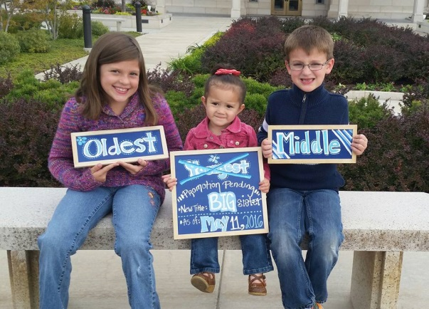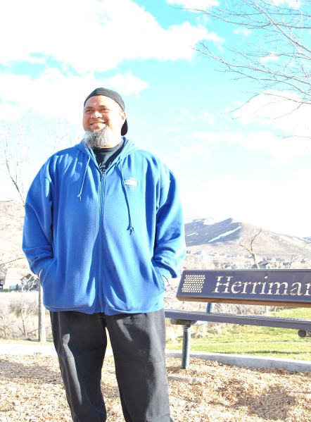
(My own pictures)

