Sports Nutrition Profile:

Annie Varner

Age:28
Gender :Female
Height: 64 inches (in) 162.56 centimeters (cm) 1.6256 meters (m)
Weight: 130 pounds (lbs) 58.967 kilograms (kg)
BMI:
Wt (kg) =58.967 = 58.967 =
Ht (m²) 1.6256^2 2.6457536 22.3
BMI category: Healthy weight (18.5-24.9)
Sport/Activity: Regular Moderate Exercise
Position (if does not apply, put n/a): N/A
Training Cycle (circle one): In season Pre-season Post-season Off-season N/A
Training time requirements (hrs/wk): 6 hours per week

Estimating calorie requirements (avg/day):
1) 10 calories/lb: 1300 calories

2) Harris-Benedict:

Female: RMR = 655.1 + (9.56 x kg) + (1.85 x cm) - (4.68 x age)

1300=655.1+(9.56x58,967)+(1.85x162.56)-(4.68x28)=1388.5
1300=655.1+563.72452+300.736-131.04=1388.5=RMR
Activity factor (AF): Sedentary (little or no exercise) = RMR X 1.2
Lightly Active (light exercise/sports 1-3 days/week) = RMR X 1.375
Moderately Active (moderate exercise/sports 3-5 days/week) = RMR X 1.55
1388.5x1.55=2152
Very Active (hard exercise/sports 6-7 days/week) = RMR X 1.725
Extra Active (very hard daily exercise/sports & physical job or 2X day training) = RMR X 1.9

Total estimated energy needs (RMR x AF) =2152

3) Estimated Daily Energy (calorie) needs for training (Kundrat & Rockwell)
Activity Category | Calories/lb | Calculated calorie range/lb
Low (sedentary): | 13 – 15
Active (30 – 60min/day) | 16 – 18
Moderate (1 – 1 ½ hr/day) | 19 – 21 | 130 lbs x20=2600
High (1 ½ – 2hr/day) | 22 – 24
Very High (2 – 3hr/day) | 25 – 30

4) Estimating Daily Energy Need for Male and Female Athletes (Dunford & Doyle)
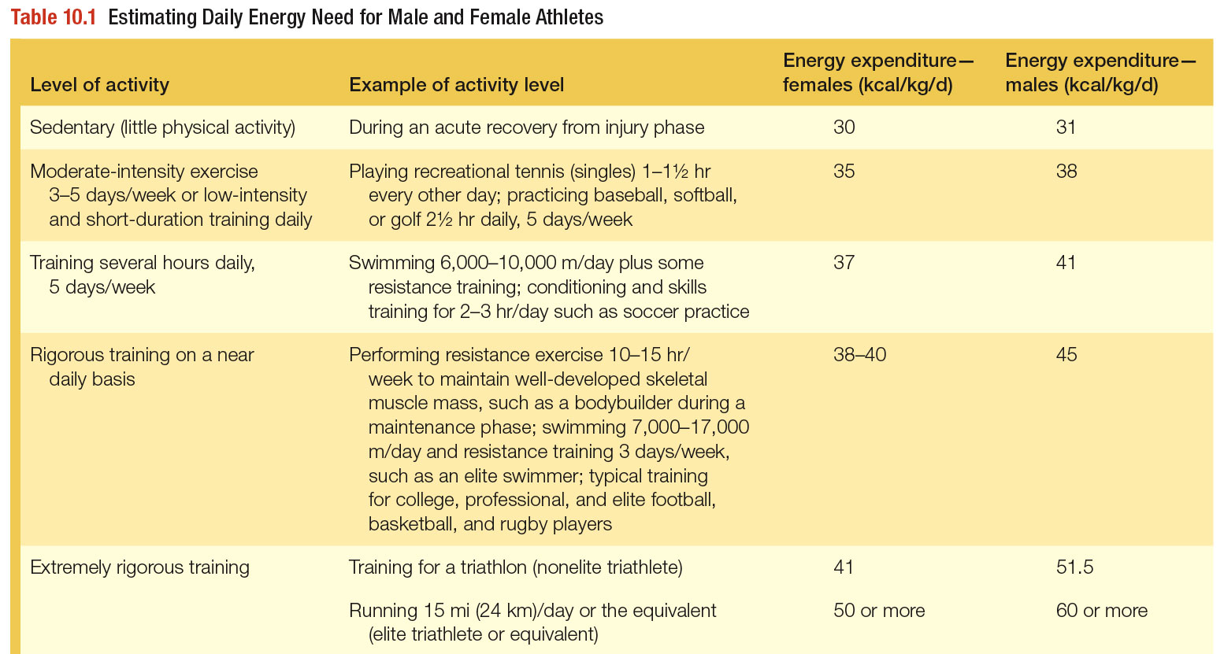
Category-Moderate-intensity exercise
3-5 days/week or low-intensity and short-duration training daily
Energy expenditure for a female: 35
(35 kcal/58.967 kg/day)=2063.8

Training
1) Training schedule for the week
2) Circle the day on which you are basing *specific needs*
Minutes/day | Monday | Tuesday | Wednesday | Thursday | Friday | Saturday | Sunday
Cardio (low intensity)
Cardio (low-moderate intensity) | 30 |  | 30 | 30 | 30 |  | 30
Cardio (moderate-high intensity)
Strength (low-moderate intensity)
Strength (moderate-high intensity) |  | 30 |  | 30 |  | 30
Flexibility | 30 |  | 30 |  | 30 |  | 30
TOTAL: 6 hours of exercise per week
 | CHO range (g/kg)  Recommended | CHO (g)  needs* | PRO range (g/kg)  Recommended | PRO (g) needs* | Fat range  (%)  Recommended | Fat (g)  needs* | Fluid (ml)  Recommended | Fluid (ml)  needs*
Daily | 7 g/kg | 413 g | 1.0 g/kg | 59 g | 1.0 g/kg | 59 g | 637-1073 ml | 787 ml
Before: 3-5 hrs before Training/Competition | 3g/kg | 177 g | N/A | N/A | N/A | N/A | 5-7 ml/kg | 295 ml
Before: 30-60 minutes before Training/Competition | 1g/kg | 59 g | N/A | N/A | N/A | N/A | 3-5 ml/kg | 177 ml
During | .5 g/kg | N/A | N/A | N/A | N/A | N/A | 150-350 ml | 300 ml
After/Recovery | 1.5g/kg | 86 g | 10-20 g | 10-15 g | N/A | N/A | 15 ml | 15 ml
NOTE: Not all boxes will have an answer – please put N/A or none; “minimal” and ounces are acceptable as well; do not leave any blank!
*Specific needs – show calculations below.
CHO:
(59kg X7g/kg=413 g CHO;
=413gx4kcal/g=1652 kcal)
PRO:
(59kgx1g/kg=59 g PRO;
=59gx4kcal/g=236 kcal)
Fat:
59 kgx1g/kg=59 g fat;
=59gx9kcal/g=531 kcal)
Fluid/Hydration: Pre-exercise weight: 130.2 lbs
Post-exercise weight: 129.2lbs
Fluid replacement range (cups) =approximately 1 cup
(In general, you should drink two cups of water for every kg of body weight loss during exercise)
Electrolytes:
Pretzels
Vitamins/minerals:
Indicate any vitamins or minerals that might become deficient/there are increased needs in this athlete’s diet:
(If none, state why not)
Calcium
Vitamin D
Iron
*Would be provided in diet with a multivitamin including all 3 of these nutrients.

“Perfect Day” meal Plan:

Monday, April 23, 2012

Breakfast
 | Calories | Fat | Carbohydrates | Protein
Milk, 1%, 1 cup | 110 | 2 | 12 | 8
Egg white, 1 serving | 17 | 0 | 0 | 5
Blueberries, fresh, 0.5 cup | 41 | 0 | 10 | 1
Raspberries, 0.5 cup | 30 | 0 | 7 | 1
Strawberries, fresh, 0.5 cup, halves | 23 | 0 | 5 | 0
Bread, whole wheat (including toast), 1 slice | 128 | 2 | 24 | 4
Blackberries, fresh, 0.5 cup | 37 | 0 | 9 | 1
Spinach, fresh, 0.5 cup | 3 | 0 | 1 | 0
*Flax Seed Meal (ground flax), 1 tbsp | 30 | 2 | 2 | 2
 | 420 | 8 | 71 | 21

Lunch
Romaine Lettuce (salad), 0.5 cup, shredded | 4 | 0 | 1 | 0
Spinach, fresh, 0.5 cup | 3 | 0 | 1 | 0
Italian Salad dressing, 2 tbsp | 137 | 14 | 3 | 0
Mangos, 1 cup, sliced | 107 | 0 | 28 | 1
Asparagus, fresh, 3 spear, small (5" long or less) | 8 | 0 | 2 | 1
Cabbage, red, fresh, 0.5 cup, chopped | 14 | 0 | 3 | 1
Cucumber (with peel), 0.5 cup slices | 7 | 0 | 1 | 0
Tomatoes, red, ripe, raw, year round average, 1 cup cherry tomatoes | 31 | 0 | 7 | 1
Applesauce, MUSSELMAN'S Lite, 1 serving | 50 | 0 | 12 | 0
 | 362 | 15 | 58 | 5

Dinner
Olive Oil, Extra Virgin, 1.5 tbs | 189 | 21 | 0 | 0
Veg: Yam, baked w/skin (1oz), 16 oz | 512 | 0 | 128 | 0
Cabbage, fresh, 0.5 cup, chopped | 11 | 0 | 2 | 1
Atlantic Salmon (fish), 3 oz | 155 | 7 | 0 | 22
Apple juice, unsweetened, 1 cup | 117 | 0 | 29 | 0
 | 983 | 28 | 159 | 22

Snack
Oranges, 1 large (3-1/16" dia) | 86 | 0 | 22 | 2
Almond Milk w/ Calcium, 1 cup | 80 | 3 | 11 | 2
Carrots, raw, 1 cup, chopped | 52 | 0 | 12 | 1
Whole Wheat Hard Pretzels, 3 oz | 308 | 2 | 69 | 9
 | 527 | 5 | 114 | 14
 | 2,292 | 57 | 401 | 63
 | 1490 - 1840 | 33 - 72 | 168 - 299 | 60 - 161

Where your calories are coming from:
Your Values10.6%67.7%21.7%FatsCarbsProteins

DISCUSSION QUESTIONS
- BMI-
- What category (normal weight, overweight, ect.) does the calculated BMI put the individual in? Do you feel BMI accurately reflects this individuals’ health and body weight?
I placed at 22.5, healthy weight; according to the BMI equation and chart. BMI is a good tool to use to get a rough estimate of weight vs. height assessment, however it is very subjective. Many factors are not considered when calculating BMI. Two factors that I would like to touch base on are bone structure and muscle mass. A person with a larger frame and bone structure can carry more weight equally distributed across the body, than someone with a smaller frame. Muscle mass is heavier then fat, and a 225 lb 5 ft body builder is not obese by any means. Ultimately, BMI does not assess body composition; however it is a good tool to use for the general population to assess disease risk related to obesity.

- What considerations and information, in addition to BMI, are needed when assessing an athlete’s body weight or body composition?
An athlete most often has more muscle mass than someone of the general population. Because of this factor, their body composition of fat free mass versus fat mass can definitely be skewed on the BMI chart. Body builders especially could have a skewed BMI reading due to their greater muscle mass. Other helpful tools that could be used to assess body mass composition are under water weighing, calipers, or a body composition scale. A scale such as the ‘Tenita Body Composition Analyzer’ will easily and quickly calculate body composition and break it down into: BMI, BMR, body fat percentage, fat mass, fat free mass, and total body water. It will also indicate the desirable range of fat mass and fat percentage for your body weight and height.

- General calorie requirements:
  - Of the three methods of estimating calories, which do you think provided the most accurate caloric estimate? Why?
I feel that the Harris-Benedict method was the most accurate because it considered the most factors. In this formula, you are taking your resting metabolic rate which is given by a formula that includes your weight in kg, height in cm, and age. Then you are using your activity level (ex. Moderate Activity) to estimate how many calories you will need to sustain your activity or sport on top of your resting metabolic rate.
  - While the methods used on the Sports Nutrition Profile are regression equations, which method of determining energy needs is the most accurate?
Again, I believe that the Harris-Benedict method is the most accurate because it considers the most factors.

- Training & Macronutrient needs:
  - What are the specific needs of this individual, which are determined by the characteristics of the sport/exercise?
For myself, I have an exercise plan consisting of cardio-aerobic exercise 5x/week, flexibility with stretching, yoga, and pilates 4x/week, and weight training 3x/week; each session lasting approximately a half hour. My exercise plan is broken down into different parts of the day, not done back to back. I use this strategy to boost my metabolism throughout the day and to promote energy for these particular parts of the day. Because my workouts are under 60 minutes, it is unnecessary to eat carbohydrates during my workout session. However, I do utilize the window period just after exercise, consuming 10-15 grams of protein and 86 grams of carbohydrates. I also replenish my water and electrolytes lost, by consuming water and sea salted whole wheat pretzels. When completing a cardio aerobic session, I consume more water do to the raise in body temperature and perspiration. In general, I make it a point to eat a high protein breakfast without empty calories or an overabundance of sugar. I eat a balanced meal consisting of a lean protein, unprocessed carbohydrate, and a healthy fat; approximately every 2-3 hours.

- Fluid/Hydration
  - Describe two methods of estimating daily fluid needs for athletes.
It is recommended that athletes drink approximately 15 ml, or 6 cups of water per kg of body weight lost during exercise. There are two very simple methods for athletes to measure hydration, and daily fluid needs.
    - Evaluation of the color of urine. There is a color chart that you can go by to assess your level of hydration. A good rule of thumb is the darker the urine is, the greater need you have for water; whereas the lighter the urine is, the less you need water.
    - You can also weigh yourself frequently. Daily/hourly weight loss is associated directly with hydration. An athlete can weigh themselves before going to sleep, and again when they wake up the next morning. This will give them an idea of how much insensible loss they have during their sleeping hours. An athlete can also weigh themselves before and after exercise to see how much fluid needs to be replenished.

- Electrolytes, Vitamins and Minerals:
  - List the vitamins and minerals which athletes may have an increased need and why.
I am not a heavy sweater when exercising, thus a large increase of sodium and potassium (electrolytes) is unnecessary for me. However, I do replenish electrolytes by eating oranges, bananas, and sea salted whole wheat pretzels. I do this to even out the water/sodium balance in the body, as well to prevent cramping; due to the association between electrolyte loss and muscle cramping during and after exercise. My greatest concerns for deficiencies of minerals and vitamins include Vitamin D, Calcium, and Iron. Vitamin D regulates cardiac and skeletal muscle. Calcium assists with Vitamin D function, and aids in muscle contraction, nerve conduction, and secretion of hormones and enzymes. Iron has a huge function as a component of hemoglobin, necessary for oxygen and carbon dioxide transport, component of enzymes necessary for cellular use of oxygen, and immune system function. Please note, another vitamin that athletes often become deficient in is Vitamin C, which aids in immune system function. My reasons for deficiency of Vitamin D and Calcium are due to insufficient intake; and my deficiency of iron usually occurs during menstruation.

- Describe your experience trying to create a “Perfect Day” meal plan.
My experience with making a perfect day meal plan was very challenging and time consuming. When trying to reach carbohydrate, protein, and fat needs, I kept falling short on carbs, and going way overboard on protein. The best way that I figured to make it work, was to up my fruit and starch vegetable intake, and reduce my portion size of meats, fish, and other protein containing sources. I found that I had to up my portion size of a yam to 16 ounces. Who eats a yam of that size? After doing this assignment, I feel that it is near impossible to achieve macronutrient recommendations as well as micronutrient recommendations without falling short or going overboard in some areas. That is why I decided to take a multivitamin to ensure that I am getting all of the necessary micronutrients that my body needs.

